**Name: Sampreet Klair**

**Student Number: 145031225**

**Student Email:** [**sklair2@myseneca.ca**](mailto:sklair2@myseneca.ca)

**Date: March 27, 2024**

**Class Diagram:**

**Account SignUp Sequence Diagram:**

|  |  |  |  |
| --- | --- | --- | --- |
| Use Case Name | timhortons.ca Account Signup | | |
| Triggering Event | Wanting to create an account on timhortons.ca | | |
| Brief Description | Allows the customer to create an account on timhortons.ca for the purpose of purchasing products from the website | | |
| Actors | User | | |
| Related Use Cases |  | | |
| Preconditions | Customer has clicked on SignIn button followed by Signup button on the website | | |
| Post Conditions | Account has been created and product purchases can now be made | | |
| Flow of activities | User | | System |
|  | 1. | Request to add a new user account. | Prompt for name, email and birthdate, and checkbox for terms and conditions. |
|  | 2. | Enters name, email, and birthdate for account creation | Create a userID and add account entry. |
|  | 3. | Prompts user to verify by typing the verification code. | Verifies user by checking and matching the verification code entered by user. |
|  | 4. | Chooses to exit and save | Saves the data. Returns to the homepage with user signed in. |
| Assumptions | * Customer does not already have an account with timhortons.ca. * Customer also agree the terms and conditions. * Customer does not enters wrong verification code. | | |
| Exception Conditions | * Customer chooses to abort creating an account. | | |

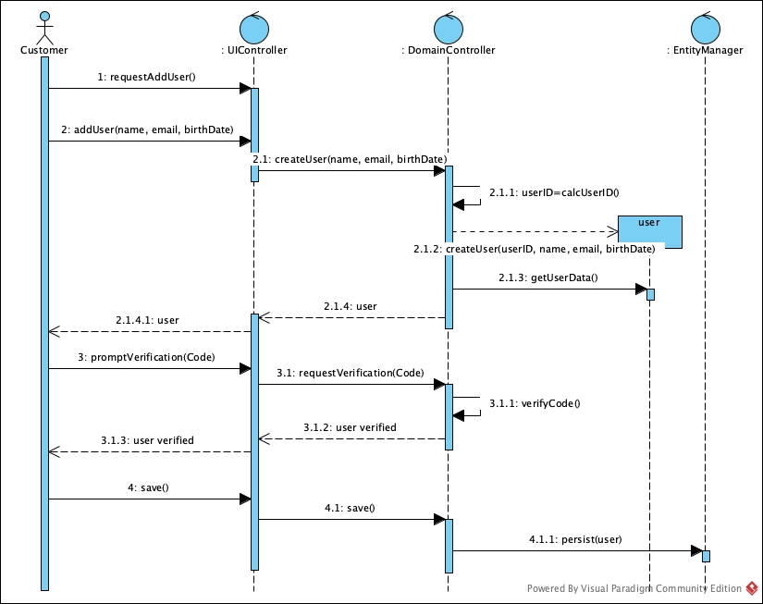

**Create Order Sequence Diagram:**

|  |  |  |  |
| --- | --- | --- | --- |
| Use Case Name | timhortons.ca order creation | | |
| Triggering Event | User must purchase products | | |
| Brief Description | Allows the user to create a new order | | |
| Actors | User | | |
| Related Use Cases |  | | |
| Preconditions | User has opened the Ordering menu | | |
| Post Conditions | Order is created by the user | | |
| Flow of activities | User | | System |
|  | 1. | Requests to create a new order | Displays a list of locations and prompts for selection. Verifies a location is selected. |
|  | 2. | Selects a product category | Displays a list of product categories and prompt for selection. Verifies a category is selected. |
|  | 3. | Enter products to add in the cart | Displays the name, price, and quantity of every product.  Verifies that name, and quantity of a product have been entered.  Creates/updates a unique orderID. |
|  | 4. | Repeats above 2 steps until all products entered | Proceed to cart and prompts to confirm checkout. |
|  | 5. | Proceed to checkout | Calculates extended price * quantity.  Calculates HST.  Updates Total. |
|  | 6. | Initialize payment processing | Proceeds to payment gateway. Verifies that payment was made. |
|  | 7. | Proceeds to save order details | Saves the order.  Return to home page. |
| Assumptions | * Customer proceeds and completes the payment. | | |
| Exception Conditions | * Owner chooses to cancel adding the sale | | |

**Screenshots of timhortons.ca website:**

timhortons.ca Homepage (before signing up) that welcomes new users.

SignUp page for new users where users enter their Name, Email and Date of Birth while also checking the private policy, terms and conditions, and terms of service checkbox.

Verification page for verifing email entered by user using an OTP sent to the user’s email address.

Page with a list of locations to be selected by the user.

Page with a list of Product Categories to be selected by the user.

Page with product information that can be added in the cart by user.

Checkout page with order details including product name, price (with tax) and quantity.

Payment gateway page for payment processing.

**Reflection:**

I chose this website as my Individual Assignment topic because first and foremost Tim Hortons is a very popular brand in Canada and timhortons.ca is a website with relatively more visitors, so I thought by working on designing it and making it’s class diagram and sequence diagrams I can get exposure of how large websites work. Secondly, I am a regular customer of Tim Hortons and am fairly familiar to this website which I thought would aid me in completing this assignment. Thirdly, I am a person who likes food and loves a good cup of coffee in the morning, so this topic resonated with me.

The thing I liked about this website is the simple and clean UI/UX design it has. I found the process from Signing Up to Checking out pretty smooth, seamless and clutter free which helped me not only as a Software Analyst/Designer but also as a user who order products using the website.

The thing I didn’t like about this website is that in the signup process there is no prompt for entering or creating passwords which I thought could lead to security vulnerabilities. Instead of using a secure user generated password, this website relies on One Time Password send to the user’s email which according to me lacks some assurance. To improve this I would suggest using the exisitng One Time Passwords alongside strong user generated passwords that would ensure 2 Factor Authentication and more security for the user.